**UNIT-II**



**RPA Concepts**: Processes & Flowcharts, Programming Constructs in RPA, What Processes can be Automated, Types of Bots, Workloads which can be automated, RPA Advanced Concepts, Standardization of processes, RPA Development methodologies, Difference from SDLC, Robotic **R**c**P**o**A**nt**C**ro**o**l**n**fl**c**o**e**w**pt**a**s**rchitecture, RPA business case, RPA Team, Process Design Document/Solution Design

Document, Industries best suited for RPA, Risks & Challenges with RPA, RPA and emerging ecosystem.

# Processes & Flowcharts:

A process flowchart is a diagram that shows the sequential steps of a process and the decisions needed to make the process work. In Robotic Process Automation (RPA), process flowcharts are used to map out the steps of a manual process that can be automated.

The following is an example of a process flowchart for a simple RPA process: Start

* Get customer information from website
* Check if customer is eligible for loan
* If eligible, generate loan offer
* If not eligible, send notification to customer End

This flowchart shows the three main steps of the process: getting customer information, checking eligibility, and generating a loan offer. The decision diamond shows the point at which the process branches, depending on whether the customer is eligible for a loan.

Process flowcharts are an important tool for RPA because they help to visualize the steps of a process and identify opportunities for automation. By mapping out the steps of a process, RPA developers can identify the tasks that can be automated and the tasks that need to be performed by humans.

Here is a diagram of the process flowchart above:

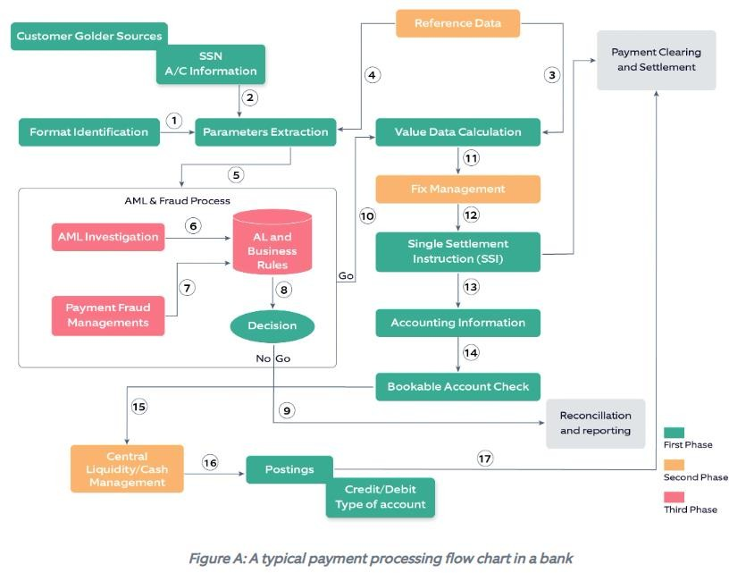

The start and end nodes are represented by circles, the steps of the process are represented by rectangles, and the decision diamond represents the point at which the process branches.

Process flowcharts can be created using a variety of tools, including flowcharting software, whiteboards, and pen and paper. Once a process flowchart has been created, it can be used to develop an RPA solution.

Here are some of the benefits of using process flowcharts in RPA:

* They help to visualize the steps of a process and identify opportunities for automation.
* They can be used to communicate the process to stakeholders.
* They can be used to document the process.
* They can be used to track changes to the process.

If you are considering using RPA to automate a process, I recommend that you start by creating a process flowchart. This will help you to understand the process and identify the tasks that can be automated.

# Programming Constructs in RPA:

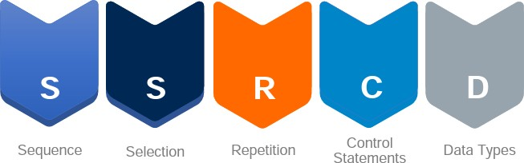Programming constructs are the backbone of any programming language. Some important programming constructs are:

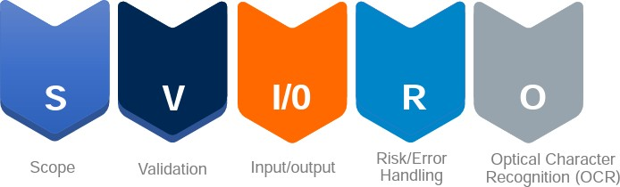They are the instructions that tell the computer what to do.

While RPA tools often provide graphical interfaces for creating automation workflows, these workflows are typically based on programming concepts and constructs. Here are some common programming constructs used in RPA:

1. **Variables**: Variables are used to store and manipulate data during the execution of an RPA process. They can hold different types of data such as numbers, text, dates, or Boolean values. Variables allow you to store temporary values, perform calculations, and make decisions based on their values.
2. **Control Structures:** Control structures enable you to control the flow of execution in an RPA process. The most common control structures are:
   1. **Conditional Statements:** Conditional statements allow you to make decisions based on certain conditions. The commonly used conditional statements are "if-else" statements and "switch" statements. These statements help you execute different actions or workflows based on specific conditions.
   2. **Loops:** Loops enable you to repeat a series of actions or a block of code until a certain condition is met. Commonly used loop constructs in RPA are "for" loops, "while" loops, and "do-while" loops.
3. **Functions:** Functions are reusable blocks of code that perform specific tasks. They take input parameters, perform a set of actions, and return a result. Functions help in modularizing your code and make it more organized, readable, and maintainable.
4. **Error Handling:** Error handling constructs allow you to handle and manage exceptions or errors that may occur during the execution of an RPA process. These constructs include try-catch blocks, where you can catch and handle specific exceptions gracefully, and throw statements, which allow you to raise custom exceptions.
5. **Data Structures:** Data structures are used to organize and store data in a structured manner. RPA processes often work with various data formats like arrays, lists, dictionaries, or tables. These data structures enable efficient data storage, retrieval, and manipulation.
6. **Libraries and APIs:** RPA tools often provide libraries and APIs (Application Programming Interfaces) that allow you to interact with external systems or applications. These constructs enable you to connect to databases, invoke web services, interact with files, or perform other integration tasks.
7. **Event Handling:** RPA processes can be triggered by various events, such as user actions, system events, or scheduled events. Event handling constructs allow you to define actions or workflows that should be executed when a specific event occurs.

These are some of the common programming constructs used in RPA. However, the specific constructs and syntax may vary depending on the RPA tool or programming language you are using.

# What Processes can be automated:

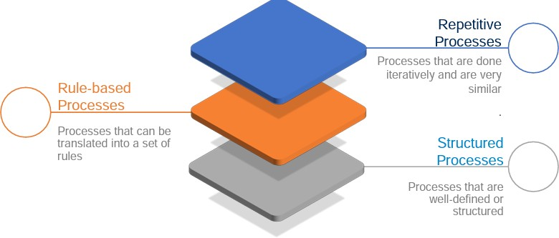Processes that are simple, structured and can be easily mimicked by a machine are best suited for RPA.

## Rule-based processes:

Rule-based processes refer to processes or tasks that can be automated based on a set of predefined rules or conditions. These processes typically involve structured data and follow specific guidelines or instructions. Here are some examples of rule-based processes that are commonly automated using RPA:

* 1. **Data Validation and Verification:** RPA can automate the process of validating and verifying data against predefined rules. For example, checking if a customer's address matches the postal code, verifying the accuracy of financial data, or ensuring that data meets specific formatting requirements.
  2. **Decision Making and Rule Execution**: RPA can automate decision-making processes based on predefined rules. For instance, automatically approving or rejecting loan applications based on predefined credit score criteria, applying specific discount rules during pricing calculations, or determining eligibility for certain benefits or services based on predefined criteria.
  3. **Compliance Monitoring and Enforcement**: RPA can automate compliance-related processes by monitoring activities and ensuring adherence to regulatory rules. This can include tasks such as checking for compliance with data privacy regulations, flagging suspicious transactions for further investigation, or enforcing access control rules.
  4. **Routing and Workflow Management:** RPA can automate the routing and management of tasks based on predefined rules. For example, automatically assigning incoming support tickets to the appropriate department or agent based on the nature of the issue, routing purchase orders to specific approvers based on predefined thresholds, or dynamically adjusting the workflow based on predefined conditions.
  5. **Exception Handling and Error Resolution**: RPA can automate the handling of exceptions and errors based on predefined rules. This can include tasks such as identifying and resolving data discrepancies or inconsistencies, automatically escalating issues that meet certain criteria, or triggering specific actions based on predefined error codes or patterns.
  6. **Calculation and Data Manipulation**: RPA can automate calculations and data manipulation tasks based on predefined formulas or rules. This can involve tasks such as calculating prices or discounts, aggregating data from multiple sources, performing complex data transformations, or generating reports based on predefined calculations.

## Repetitive processes:

Repetitive processes refer to tasks or activities that are performed repeatedly with little or no variation. These tasks often involve following a set of predefined steps or instructions and can be time-consuming and monotonous. Automating repetitive processes using RPA (Robotic Process Automation) can help increase efficiency, reduce errors, and free up human resources for more valuable work. Here are some examples of repetitive processes commonly automated using RPA:

* 1. **Data Entry and Data Migration:** RPA can automate the process of entering data from one system to another by extracting information from source documents or databases and populating the data fields in the target system. This includes tasks such as copying data from spreadsheets, invoices, or forms into a database or CRM system.
  2. **Report Generation:** RPA can automate the generation of reports by pulling data from multiple sources, performing calculations or data manipulations, and generating formatted reports in various formats (e.g., Excel, PDF) on a scheduled basis or upon request.
  3. **Email Processing:** RPA can automate repetitive email processing tasks, such as sorting and categorizing incoming emails, extracting relevant data from emails and attachments, and performing predefined actions or routing based on specific criteria.
  4. **File and Document Handling**: RPA can automate tasks related to file and document management, including file organization, renaming, copying, moving, or archiving files. It can also automate tasks like document formatting, merging or splitting documents, or extracting specific information from documents.
  5. **Data Extraction and Web Scraping**: RPA can automate the process of extracting data from websites, online portals, or other sources. This includes tasks such as scraping product information from e- commerce websites, extracting news headlines from news websites, or gathering data from online forms.
  6. **Data Validation and Quality Control**: RPA can automate the process of data validation and quality control by comparing data against predefined rules or criteria, identifying inconsistencies or errors, and taking corrective actions or generating error reports.
  7. **Reconciliation and Auditing**: RPA can automate repetitive reconciliation processes, such as comparing data between different systems or databases to ensure consistency and accuracy. It can also automate auditing tasks by scanning data or transactions for anomalies, performing calculations, and generating audit reports.
  8. **Data Backup and Transfer**: RPA can automate the process of data backup and transfer by scheduling regular backups, copying or transferring data between systems or storage locations, and verifying the integrity of transferred data.

## Structured processes:

Structured processes refer to well-defined and standardized workflows that follow a specific sequence of steps or actions. These processes have clear inputs, outputs, and predefined rules or guidelines to be followed. Automating structured processes using RPA (Robotic Process Automation) can help streamline operations, increase efficiency, and reduce errors. Here are some examples of structured processes commonly automated using RPA:

* 1. **Order Processing:** RPA can automate the end-to-end process of order processing, starting from order entry to fulfilment. This includes tasks such as capturing order details, validating order information, checking inventory levels, generating purchase orders, and updating order status.
  2. **Employee On-boarding:** RPA can automate the process of employee on-boarding by following a predefined set of steps. This includes tasks such as collecting new hire information, setting up accounts and access permissions, generating employee documentation, and notifying relevant stakeholders.
  3. **Invoice Processing**: RPA can automate the structured process of invoice processing, including tasks such as extracting invoice data, matching invoices with purchase orders or receipts, verifying invoice details, routing invoices for approval, and updating financial systems.
  4. **Loan Application Processing:** RPA can automate the structured workflow of loan application processing, from application submission to approval or rejection. This includes tasks such as capturing applicant information, verifying documentation, performing credit checks, calculating loan eligibility, and generating approval notifications.
  5. **Claims Processing:** RPA can automate the structured process of claims processing in insurance or healthcare sectors. This includes tasks such as capturing claim information, validating coverage details, verifying supporting documents, calculating claim amounts, and processing claim payments.
  6. **Travel Expense Management:** RPA can automate the process of travel expense management by following a predefined workflow. This includes tasks such as capturing expense details, validating receipts, applying expense policies, calculating reimbursement amounts, and generating expense reports.
  7. **Compliance Audits**: RPA can automate the structured process of compliance audits by following predefined audit procedures. This includes tasks such as collecting audit evidence, performing checks against compliance regulations, identifying gaps or violations, generating audit reports, and tracking corrective actions.
  8. **Customer Service Requests:** RPA can automate structured customer service processes, such as handling common customer requests or inquiries. This includes tasks such as capturing customer information, retrieving relevant data from systems, providing standardized responses, and updating customer records.

# Types of Bots:

A robot is software that can execute workflows containing multiple steps.

* It can mimic human actions such as type, click and read data.
* It can perform complex calculations and decision making.
* It can log into applications, move files/folders, and copy paste data.

In RPA, robots are categorized on the basis of manual intervention required.

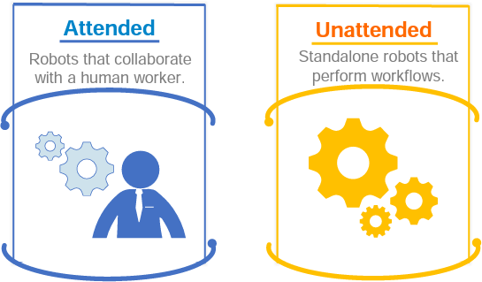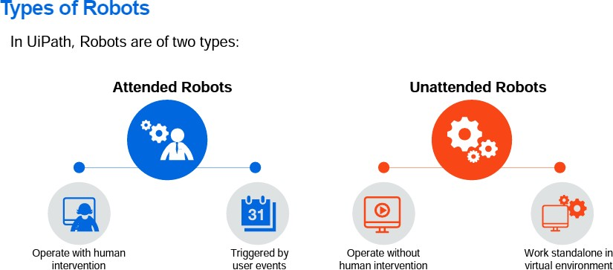

1. **Attended:** It operates on the same workstation as a human to help the user accomplish daily tasks. It is usually triggered by user events. You cannot start a process from Orchestrator on these type of Robots, and they cannot run under a locked screen.
2. **Unattended:** It can run unattended in virtual environments and can automate any number of processes. In addition to the Attended Robot's capabilities, this Robot is responsible for remote execution, monitoring, scheduling, and providing support for work queues.
3. **Free:** It is similar to Unattended Robots, but can be used only for development and testing purposes, not in a production environment.

# Workloads which can be automated:

1. **Orchestrating Big Data Pipelines**: Workload automation can be used to schedule and manage complex data processing pipelines, including data ingestion, data transformation, data cleansing, and data analysis tasks in big data environments such as Hadoop or Spark.
2. **Managed File Transfer (MFT):** Workload automation tools can automate file transfers between systems, including secure and encrypted file transfers, ensuring reliable and timely movement of data between different locations and systems.
3. **Performance Dashboards**: Workload automation can collect data from various sources, perform data aggregation and analysis, and generate performance dashboards or reports that provide real-time insights into system performance, resource utilization, and key performance indicators (KPIs).
4. **Integrating Operating Systems and Web Services:** Workload automation tools often have capabilities to interact with different operating systems and web services through REST APIs. This allows organizations to automate and integrate processes across multiple platforms, systems, and applications.
5. **Machine Learning Workflows:** Workload automation can orchestrate the end-to-end process of training, validating, and deploying machine learning models. This includes tasks such as data preparation, model training, hyper-parameter tuning, model evaluation, and deployment to production environments.
6. **Meeting Service Level Agreements (SLAs):** Workload automation enables organizations to meet SLAs by automating critical tasks and processes. It can monitor SLA deadlines, trigger actions or notifications based on predefined thresholds, and escalate issues to ensure timely completion of tasks.

# RPA Advanced Concepts:

Robotic Process Automation (RPA) has evolved beyond basic automation capabilities to encompass more advanced concepts and techniques. Here are some advanced concepts in RPA:

* 1. **Intelligent Automation:** Intelligent Automation combines RPA with Artificial Intelligence (AI) technologies such as Machine Learning (ML) and Natural Language Processing (NLP). This enables robots to perform complex tasks that involve decision-making, data analysis, and interacting with unstructured data sources.
  2. **Cognitive Automation:** Cognitive Automation goes a step further by incorporating advanced cognitive capabilities into RPA systems. This includes capabilities like computer vision, speech recognition, sentiment analysis, and predictive analytics. It allows robots to perceive and understand the environment, making them more intelligent and adaptable.
  3. **Machine Learning and AI Integration**: RPA can be integrated with machine learning algorithms and AI models to enable intelligent decision-making and data analysis. Machine learning algorithms can be used to train robots to handle exceptions and learn from historical data, improving their performance and accuracy over time.
  4. **Natural Language Processing:** RPA can leverage Natural Language Processing techniques to understand and process human language. This enables robots to interact with users through chat bots, voice assistants, or email, understanding and responding to their queries or instructions.
  5. **Unstructured Data Processing**: RPA traditionally excels in structured data processing, but advanced RPA systems can now handle unstructured data as well. With the help of AI technologies, robots can extract relevant information from documents, emails, invoices, and other unstructured sources, allowing for more comprehensive automation.
  6. **Process Discovery and Mining:** RPA can utilize process mining and discovery techniques to analyze existing business processes and identify automation opportunities. By capturing and analyzing data from various sources, RPA systems can identify inefficiencies, bottlenecks, and repetitive tasks that can be automated.
  7. **Advanced Analytics and Reporting**: RPA systems can generate advanced analytics and reports by collecting and analyzing data from multiple processes. These insights can help identify trends, patterns, and areas for improvement, enabling organizations to make data-driven decisions and optimize their operations.
  8. **Orchestrating Multiple Bots**: Advanced RPA platforms allow for the coordination and orchestration of multiple bots to work together seamlessly. This enables the automation of end-to-end processes that span across multiple systems and applications.
  9. **Integration with Enterprise Systems**: RPA can integrate with existing enterprise systems such as Customer Relationship Management (CRM) software, Enterprise Resource Planning (ERP) systems, and legacy applications. This integration enables robots to access and update data in real-time, ensuring data consistency and eliminating manual data entry.
  10. **Governance and Compliance:** Advanced RPA systems provide features for governance and compliance, including access controls, audit trails, and compliance reporting. These features ensure that RPA deployments adhere to regulatory requirements and internal policies, providing transparency and accountability.

# Standardization of processes:

Standardization of processes is a critical aspect of effective process management and automation, including Robotic Process Automation (RPA). It involves defining consistent and optimized procedures, rules, and guidelines for performing specific tasks or activities within an organization. Here are some key points regarding the standardization of processes:

1. **Consistency and Efficiency:** Standardizing processes ensures that tasks are executed consistently across different teams, departments, or locations. It eliminates variations in how activities are performed, leading to greater efficiency, reduced errors, and improved quality of outputs.
2. **Process Mapping and Documentation:** The first step in standardization is to map out and document existing processes. This involves identifying the sequence of steps, inputs, outputs, and decision points within a process. Process maps or flowcharts provide a visual representation of the workflow and serve as a reference for standardization efforts.
3. **Best Practices Identification:** Standardization involves identifying and documenting best practices within a process. This includes determining the most efficient and effective ways of performing tasks, based on previous experience, industry standards, or benchmarking against other organizations. Best practices become the reference point for standardizing processes.
4. **Streamlining and Optimization:** Standardization offers an opportunity to streamline and optimize processes. By eliminating redundant steps, reducing complexity, and automating repetitive tasks, organizations can achieve greater process efficiency, faster turnaround times, and cost savings.
5. **Compliance and Governance:** Standardizing processes ensures that activities are performed in accordance with regulatory requirements and internal policies. It promotes compliance by embedding control mechanisms, ensuring data security, and enabling proper auditing of processes. Standardized processes also facilitate governance by providing visibility, accountability, and traceability.
6. **Training and Onboarding**: Standardized processes make it easier to train new employees or onboard team members. With clearly defined procedures and guidelines, individuals can quickly understand their roles and responsibilities, follow standardized workflows, and contribute effectively to the organization's goals.
7. **Continuous Improvement:** Standardized processes serve as a baseline for continuous improvement initiatives. By establishing metrics, monitoring performance, and gathering feedback, organizations can identify areas for enhancement, implement changes, and iterate on the standardized processes over time.
8. **Integration with Automation Technologies:** Standardized processes form the foundation for successful implementation of automation technologies like RPA. When processes are standardized, it becomes easier to identify automation opportunities, design efficient workflows, and deploy robots to execute tasks consistently and accurately.
9. **Communication and Collaboration:** Standardized processes foster effective communication and collaboration among team members. With clearly defined roles, responsibilities, and expectations, employees can work together more efficiently, share knowledge and insights, and align their efforts towards common goals.
10. **Scalability and Replicability:** Standardized processes enable organizations to scale their operations and replicate successful practices across different teams or business units. It ensures consistency and maintains the desired level of quality as the organization grows or expands into new areas.

# RPA Development methodologies

When it comes to developing Robotic Process Automation (RPA) solutions, there are various methodologies and approaches that organizations can adopt. Here are some common RPA development methodologies:

1. **Waterfall Methodology:** The waterfall methodology follows a linear, sequential approach to RPA development. It involves distinct phases, such as requirements gathering, design, development, testing, and deployment, with each phase completed before moving on to the next. This methodology is suitable for straightforward and well-defined RPA projects with stable requirements.
2. **Agile Methodology:** Agile is an iterative and flexible development methodology that emphasizes collaboration, adaptability, and quick iterations. It involves breaking down the RPA project into smaller increments called sprints, where development, testing, and deployment occur in short cycles. Agile promotes continuous feedback, close customer involvement, and the ability to accommodate changes and evolving requirements.
3. **DevOps:** DevOps is a methodology that combines software development (Dev) and IT operations (Ops) to streamline the development and deployment processes. In the context of RPA, DevOps focuses on automating the deployment, monitoring, and management of RPA solutions. It emphasizes collaboration between development and operations teams, continuous integration and delivery, and rapid response to changes.
4. **Prototype-based Methodology:** This methodology involves building quick and simple prototypes to demonstrate the feasibility and potential of an RPA solution. The prototypes help stakeholders visualize the proposed automation, gather feedback, and refine requirements before proceeding with full-scale development. It enables rapid experimentation and validation of ideas.
5. **Hybrid Methodologies:** Organizations often customize and combine different methodologies to suit their specific RPA development needs. For example, a hybrid approach may involve incorporating elements of waterfall, agile, and DevOps methodologies to accommodate the unique requirements, timeline, and complexity of an RPA project.

Regardless of the chosen methodology, there are certain best practices that can enhance RPA development:

1. **Clear Requirements Definition:** Clearly define and document the business requirements, scope, and objectives of the RPA project. This ensures a common understanding among stakeholders and provides a foundation for development.
2. **Process Analysis and Design:** Conduct a thorough analysis of the target processes to identify automation opportunities, document process flows, and design efficient workflows. Consider factors such as exceptions, error handling, and data security.
3. **Collaborative Approach:** Foster collaboration and communication between business stakeholders, RPA developers, and subject matter experts. Regular meetings, feedback sessions, and knowledge sharing ensure that the developed solution meets the actual business needs.
4. **Testing and Quality Assurance:** Implement a robust testing strategy to verify the functionality, reliability, and performance of the RPA solution. Include unit testing, integration testing, user acceptance testing, and performance testing to identify and address any issues or bugs.
5. **Version Control and Documentation:** Utilize version control systems to track changes to the RPA solution's code and configuration. Maintain comprehensive documentation to aid in future maintenance, troubleshooting, and knowledge transfer.
6. **Change Management:** Implement change management practices to effectively manage and communicate changes introduced by the RPA solution. Ensure that users are adequately trained, and any potential impacts or risks are addressed.

Adopting an appropriate RPA development methodology and adhering to best practices contribute to the successful implementation and adoption of RPA solutions within organizations.

# Difference from SDLC

While there are similarities between the development of Robotic Process Automation (RPA) solutions and the traditional Software Development Life Cycle (SDLC), there are also some key differences. Here are the main distinctions between RPA development and SDLC:

1. **Focus:** The primary focus of RPA development is on automating repetitive tasks and processes, whereas SDLC is focused on building custom software applications to address specific business requirements. RPA aims to automate existing processes without significant changes to the underlying systems, while SDLC involves building software from scratch or making extensive modifications to existing applications.
2. **Scope:** RPA development typically has a narrower scope compared to SDLC. RPA projects often target specific processes or tasks within an organization for automation. In contrast, SDLC encompasses the full lifecycle of software development, including requirements gathering, design, development, testing, deployment, and maintenance.
3. **Requirements:** RPA development typically involves capturing and documenting the requirements related to the specific processes being automated. The requirements are often based on the existing manual processes and focus on automating the steps and tasks involved. In SDLC, the requirements are typically broader and encompass a wide range of functional and non-functional aspects of the software application being developed.
4. **Customization vs. Configuration**: In SDLC, software applications are often built from scratch or heavily customized to meet specific business needs. RPA, on the other hand, focuses more on configuration rather than customization. RPA developers configure the automation software to interact with existing systems and applications, leveraging their existing functionalities
5. **Iterative vs. Incremental:** While both RPA development and SDLC can involve iterative and incremental approaches, the nature of iterations is different. In RPA development, iterations often revolve around refining and enhancing the automation of specific processes, focusing on incremental improvements. In SDLC, iterations typically involve adding new features, addressing feedback, and delivering updated versions of the software application.
6. **Development Tools and Technologies:** RPA development involves using specialized tools and platforms designed specifically for creating, managing, and deploying automation bots. These tools provide drag-and-drop interfaces, automation recorders, and integration capabilities with different systems. In SDLC, a wide range of programming languages, frameworks, and development tools are used based on the specific technology stack and requirements of the software application.
7. **Timeframe:** RPA development projects tend to have shorter timeframes compared to typical SDLC projects. RPA solutions often aim for quick returns on investment by automating repetitive tasks and achieving efficiency gains within a relatively short period. SDLC projects, especially larger ones, usually have longer timeframes due to the complexity involved in building custom software applications.

It's important to note that RPA development can be a part of a broader SDLC process if it involves building or modifying software applications to enable automation. However, the key differentiating factors lie in the specific goals, scope, focus, and requirements of RPA development compared to the traditional SDLC.

# Robotic Process Automation (RPA) Business Case:

## Improved Efficiency and Productivity

One of the primary benefits of RPA is improved efficiency and productivity. RPA software robots can automate repetitive, rule-based tasks that are time-consuming for humans to complete with greater speed and accuracy than even the most focused employee could. This increased speed can enable organizations to process more work in less time, reducing bottlenecks and improving overall efficiency. Since robots don’t get tired, they can also improve accuracy and reduce the likelihood of errors when processing large quantities of data.

## Cost Reduction

By automating repetitive tasks, companies can reduce the need for human involvement in tedious, time- consuming tasks, leading to significant cost savings. This can free up resources that can be invested in other areas of the business, such as research and development or marketing. In addition, RPA can also help companies avoid the costs associated with hiring and training new employees. With the ability to automate tasks, businesses can reduce the need for additional staff and instead invest in technology to help them achieve their goals more efficiently.

## Improved Customer Experience

RPA can also improve the customer experience by reducing the time required to complete specific tasks. For example, RPA can automate the processing of customer inquiries, leading to faster response times and improved customer satisfaction. This can help organizations retain customers, as customers are likelier to remain loyal to a business that provides excellent, timely service.

## Scalability

RPA solutions can quickly scale up or down based on the needs of the business. Since RPA is based on software robots, it can be quickly reconfigured and updated as business needs, industry trends, or demand changes. Additionally, since RPA is based on software robots, it can be quickly reconfigured and updated as business needs change. This allows companies to stay agile and respond quickly to changing market conditions. It is a compelling solution for businesses looking to improve efficiency, reduce costs, and remain competitive in a rapidly changing marketplace.

## Data Management

Data management is essential to any business, and RPA can help streamline this process. RPA can [automate data entry,](https://solutionsreview.com/business-process-management/the-art-of-leveraging-data-and-automation-in-2023/) validation, and reconciliation, significantly reducing the time required for manual data processing. This can improve data accuracy, reduce the risk of errors, and allow organizations to make informed decisions based on reliable data.

## Compliance and Security

RPA can also help organizations achieve compliance and maintain security standards. For example, RPA can help ensure data security by automating data encryption, access control, and other security measures. This can help prevent unauthorized access to sensitive data and protect against breaches. It can also improve a company’s compliance with regulations and standards by automating processes and ensuring data is processed accurately and consistently. RPA can also provide audit trails and other documentation to demonstrate compliance with regulatory requirements.

# RPA Team:

An RPA team is a group of people who are responsible for the implementation, development, and maintenance of robotic process automation (RPA) solutions. The team typically includes a variety of roles, such as:

* + - **RPA developers:** These are the people who create and code the RPA bots. They need to have a strong understanding of both RPA technology and the specific business processes that the bots will be automating.
    - **RPA analysts:** These are the people who work with the business users to identify and prioritize processes that are good candidates for automation. They also need to have a good understanding of RPA technology.
    - **RPA testers:** These are the people who test the RPA bots to make sure that they are working correctly. They need to have a strong understanding of both RPA technology and the specific business processes that the bots are automating.
    - **RPA operations:** These are the people who deploy and maintain the RPA bots in production. They need to have a good understanding of both RPA technology and the IT infrastructure that the bots will be running on.

## In addition to these core roles, an RPA team may also include other roles, such as:

* + - **RPA project manager:** This person is responsible for managing the RPA project from start to finish. They need to have a strong understanding of both RPA technology and project management principles.
    - **RPA architect:** This person is responsible for designing the overall RPA architecture. They need to have a strong understanding of both RPA technology and the organization's IT architecture.
    - **RPA trainer:** This person is responsible for training the business users on how to use the RPA bots. They need to have a strong understanding of both RPA technology and the specific business processes that the bots are automating.

The size and composition of an RPA team will vary depending on the size and complexity of the organization's RPA program. However, all RPA teams should have the core roles listed above in order to be successful.

## Here are some of the benefits of having an RPA team:

* + - **Increased efficiency:** RPA can automate repetitive and time-consuming tasks, freeing up human workers to focus on more strategic and value-added activities.
    - **Improved accuracy:** RPA bots can be programmed to follow strict rules, which can help to reduce errors.
    - **Reduced costs:** RPA can help to reduce costs by automating tasks that would otherwise be performed by human workers.
    - **Improved compliance:** RPA can help organizations to comply with regulations by automating tasks that require strict adherence to rules.

If you are considering implementing RPA in your organization, it is important to have a dedicated RPA team in place to manage the project and ensure that it is successful.

**Task Capture:**

# Process Design Document/Solution Design Document

UiPath Task Capture is a process discovery tool that helps you deep-dive into automation ideas, enabling you to quickly capture, enhance and accelerate the automation by sharing the specifics of your work.

Once you identify potential automation candidates in [Automation Hub,](https://docs.uipath.com/automation-hub/docs/submit-idea) use Task Capture to provide the expertise about the particular task, and help you speed up the automation process.

## Installation:

The installation process can be made, depending on each customer need through two different installer file types:

* the TaskCapture.exe used to install Task Capture per-user
* the TaskCapture.msi used to install Task Capture per-machine Task Capture provides you with 2 options for creating documentation:
* by building the process map from scratch and then capturing actions for each part of your process;
* by recording the actions as you perform them and automatically generating a comprehensive workflow diagram including the details about each step.

By default the tool takes screenshots with every mouse click & keyboard inputs, and collects smart data about the process statistics (execution time, number of actions, text entries, etc.). We can edit and annotate each screenshot and add information for each step. We can also specify what kind of actions to be recorded.

As a result of your efforts, with the use of Task Capture, you can present the documentation in Microsoft Word format as an insightful Process Definition Document (PDD) and use it within your team.

Export the collected information to a great range of platforms that integrate with Task Capture. Some of them are listed below:

in UiPath Studio you can export the recorded process as a workflow template (.xaml format) and start developing your automation using it as a skeleton.

in Automation Hub you can use Task Capture to document your automation ideas and bring them one step further to being automated

in Test Manager you can document the Manual Test Cases easily, using Task Capture.

## Benefits

**Data-driven approach**– the app gathers the data required to accelerate the automation by bridging the gap between two groups of business personas - SMEs and COE team.

**Eliminate manual work** – capture automatically and in the background the details for each step.

**Generate the necessary RPA documentation** – based on the collected information, the app generates ready-made PDDs and automation prototypes.

**Flexibility** – the tool works across the entire UiPath Platform and is a perfect fit for either top-down or bottom-up automation strategy.

To start process and automation ideas, select one of the three available options:

[Build Diagram](https://docs.uipath.com/task-capture/standalone/2022.4/user-guide/build-diagram) - create your own workflow diagram with all the necessary actions, then use Task Capture to take screenshots for each action and automatically capture the required data.

[Capture Process](https://docs.uipath.com/task-capture/standalone/2022.4/user-guide/capture-process) - run through the process while the tool automatically captures your actions, takes a screenshot with each mouse click, and builds a workflow diagram based on the collected data.

[Open File From PC](https://docs.uipath.com/task-capture/standalone/2022.4/user-guide/open-file-from-pc) - open saved files created with Task Capture if you need to apply any updates. You can open .ssp or .ssg file formats.

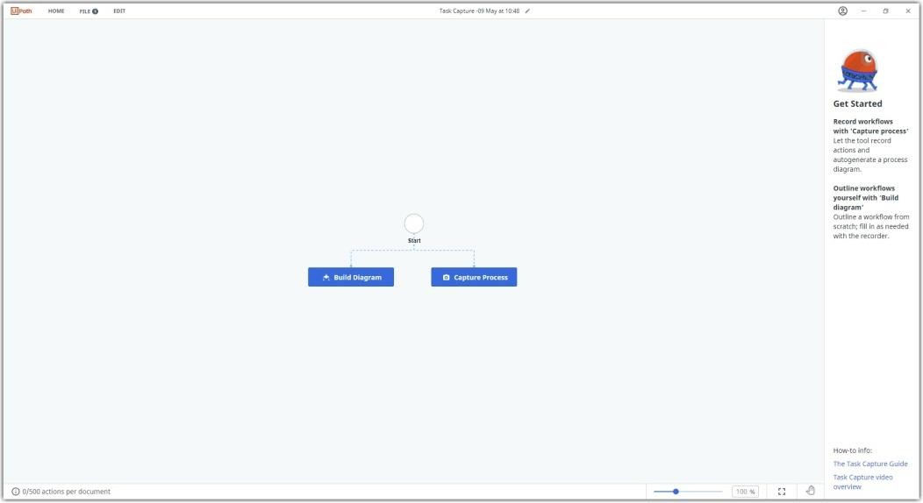

The **capturing widget** allows you to capture the process. This is displayed once you click the **Capture Process** option.

As soon as the widget is displayed a **Start Capture** button is made available allowing you to control the beginning of the capturing process.

Before you hit the **Start** button, we recommend you prepare all the relevant applications used to perform the process.



Once you click **Start Capture** the capturing begins and the following management options are displayed:

1. Pause: allowing you to avoid irrelevant data.
2. Stop: allowing you to finish the documentation process.
3. Add title: allowing you to add a relevant title to each action you capture.
4. Add description: allowing you to add a relevant description to each action you capture.

It also displays the number of actions captured and the number of remaining actions until the 500 actions limitation is reached.

**NOTE:** By default, Task Capture generates screenshots for every action you perform - mouse clicks, keyboard inputs, and hotkeys. You can specify the actions you want to record in the [Capturing](https://docs.uipath.com/task-capture/standalone/2022.4/user-guide/capture-settings) [Settings](https://docs.uipath.com/task-capture/standalone/2022.4/user-guide/capture-settings) page

## Process Title:

By default, captured processes are given a title that contains the date, the month, and the hour when the capturing of the process began.



To change the title of a captured process follows the steps below:

1. Click the **Edit** icon displayed as a pencil. This is available on the upper part of the screen in the middle of the application top panel.



1. Once the **Rename Process Document** pop-up is displayed type in the new name for your process and click **Submit**.

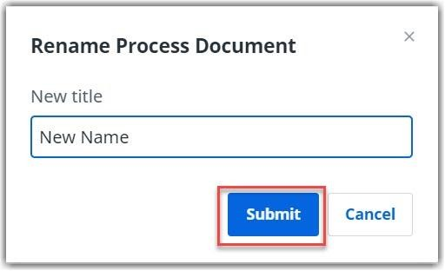

## Action Limitation

The number of captured actions in a process document impacts the performance of the application, including work with the Diagram Editor, Image Editor, exporting options, as well as the Process Definition Document. That is why the number of actions that can be captured is set up to 500. Please note that this limitation does not prevent you from creating processes with more than 500 actions, it's purpose is to provide best practices guidance in order to have the best experience while using Task Capture.

On the right-hand corner of the Diagram Builder window, you can view at all times an **action counter** allowing you to monitor the number of actions added to the entire workflow and an **Information** icon providing details about the limitation.

docs image

Furthermore, the **capturing widget** that allows you to capture the actions composing the process, displays the number of actions captured for the documented sequence and the number of remaining actions until the 500 actions limitation is reached.

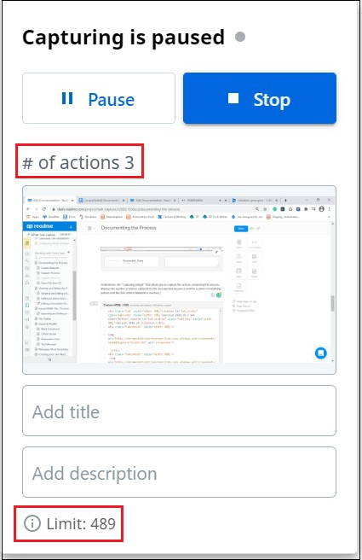

As soon as more than 500 actions per Document are captured a pop-up message is displayed allowing you to **Continue Capturing** or **Stop Capturing**.

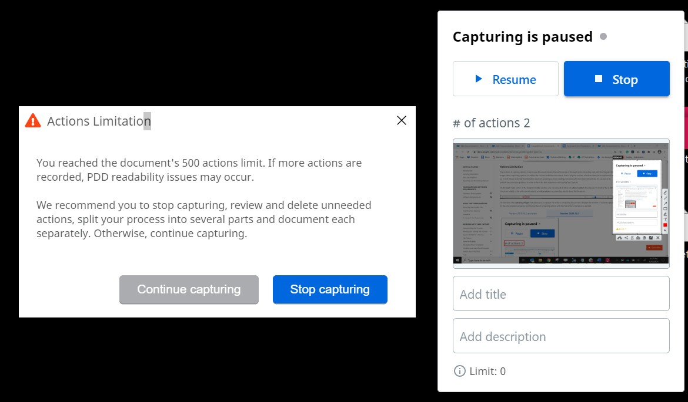

In case you choose to continue the capturing process the **capturing widget** displayed on the lower part of the pop-up, the number of actions exceeding the 500 action limitation.

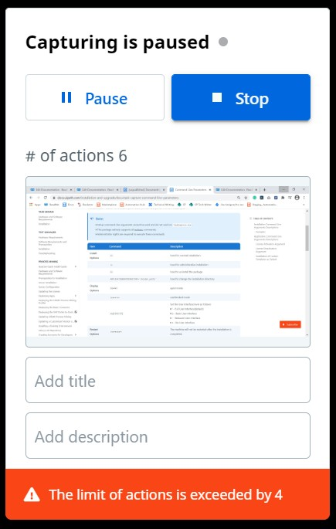

If you attempt to copy and insert or duplicate actions that results in exceeding the limitation a pop-up message is displayed allowing you to **cancel** the action or **Continue Anyway**.

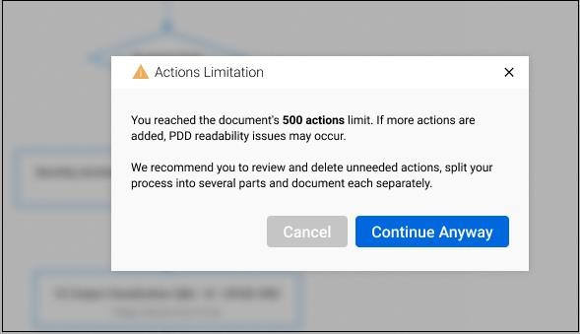

# Industries best suited for RPA:



In this digital era, increased businesses and industries are automating their workflows and operations. As for some industries who think automation is a costly effort, they are witnessing early adopters of [robotic process automation](https://www.claysys.com/robotic-process-automation-services/) outperform the rest of the organizations with an increased ROI and also round-the-clock work at reduced costs.

According to a recent [Forrester Report, RPA will be worth $2.9 billion by 2021](https://towardsdatascience.com/all-the-robotic-process-automation-rpa-stats-you-need-to-know-bcec22eaaad9). RPA is a technological breakthrough for industries as they automate the entire business workflows efficiently.

## Top Use Cases of RPA Implementation

* [**Telecommunications**](https://www.claysys.com/blog/robotic-process-automation-use-cases/#Telecommunications)
* [**Banking**](https://www.claysys.com/blog/robotic-process-automation-use-cases/#Banking)
* [**Customer Care**](https://www.claysys.com/blog/robotic-process-automation-use-cases/#Customer-Care)
* [**Insurance**](https://www.claysys.com/blog/robotic-process-automation-use-cases/#Insurance)
* [**Healthcare**](https://www.claysys.com/blog/robotic-process-automation-use-cases/#Healthcare)
* [**Manufacturing**](https://www.claysys.com/blog/robotic-process-automation-use-cases/#Manufacturing)
* [**Finance**](https://www.claysys.com/blog/robotic-process-automation-use-cases/#Finance)
* [**Property Management**](https://www.claysys.com/blog/robotic-process-automation-use-cases/#Property-Management)
* [**Retail**](https://www.claysys.com/blog/robotic-process-automation-use-cases/#Retail)
* [**Information Technology**](https://www.claysys.com/blog/robotic-process-automation-use-cases/#Information-Technology)

Robotic Process Automation allows industries to automate tasks across various systems. An industry that implements RPA can automate its entire workflow, infrastructure, and other backend processes, which are mostly labour-intensive and time-consuming.

Industries of all sizes can automate their tasks with robotic process automation that completely eliminates the risks of human errors. Let us walk through the key use cases of RPA implementation in various industry verticals:

## RPA in Telecommunications

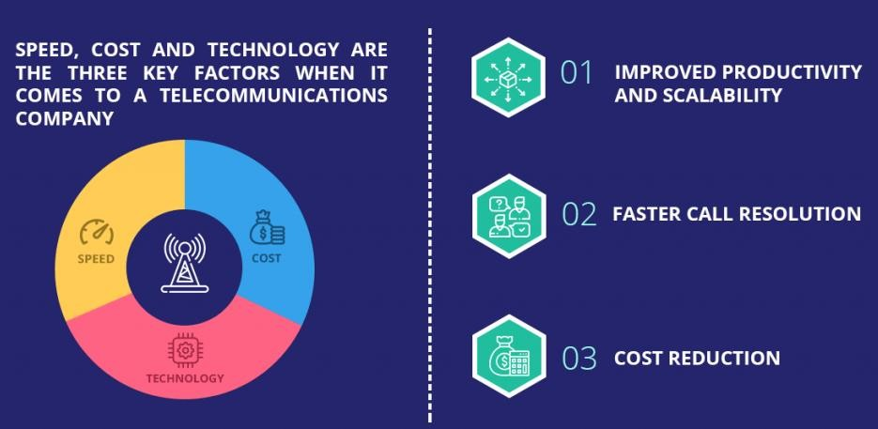

Speed, cost and technology are the three key factors when it comes to a telecommunications company. Telecom companies can take advantage of RPA in the following key areas:

### Improved Productivity and Scalability

The ability to handle large volumes of data makes the robotic process automation the best suitable go-to- market strategy for the telecommunications industry. Being able to automate back-office processes eliminates the need for employees to perform redundant tasks and focus on other critical tasks.

### First Call Resolution Benefits

RPA enables software bots to rapidly access data, thus helping the telecom agents address the customer demands on their first call without having to perform repeated follow-ups. RPA promotes FCR rates thus ensuring customer retention and loyalty.

### Cost Reduction

The major cost reduction involved with implementing RPA in telecom is that the RPA software license can be used for multiple processes. The implementation cost is also not as high as that for ERP or Business Process management. Automating tasks also leads to increased ROI.

## RPA in Banking

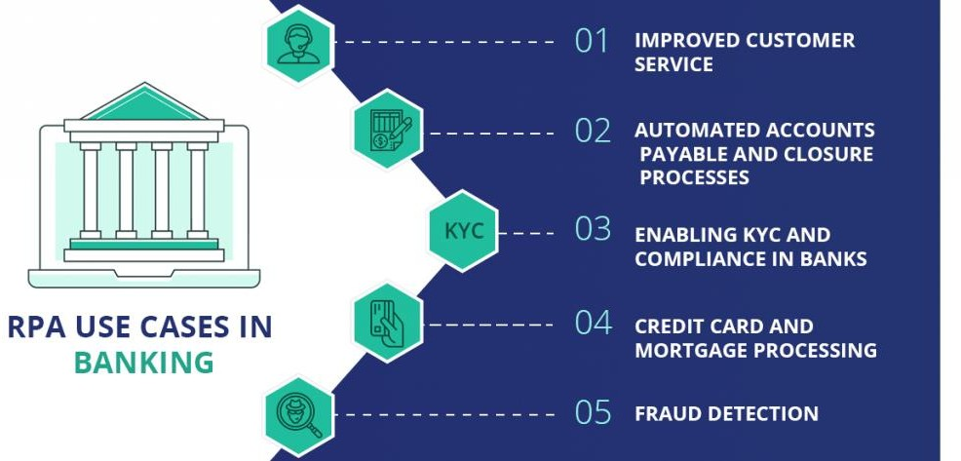

Incorporating RPA saves labour and operational costs in banks. It also reduces errors and human tasks significantly. For instance, the processing cost reduces to 30% to 70% by reducing the turnaround time with banking automation via RPA technology. The banking sector can leverage RPA in the following ways:

### Improved Customer Service

From customer on-boarding, verifying customer details to account and loan inquiry, RPA helps banks reduces the turnaround time. This helps banks retain their customers and maintain customer loyalty.

### Automated Accounts Payable and Closure Processes

The Traditional process of AP involves gathering invoices from vendors using OCR (Optical Character Recognition), validating the data in the fields thus provided and then processing it. RPA automates this entire process and credits the amount automatically to the vendor’s account.

RPA also sends automated notifications to customers prompting them to furnish necessary documents and processes account closure functions with 100% accuracy.

### Enabling KYC And Compliance In Banks

Statistics show that certain banks invest in KYC compliance figures that are close to $384 million every year. RPA is used to gather customer information, validate and process it. Fewer FTEs and round-the- clock functioning improve productivity and the quality of the compliance process.

### Credit Card And Mortgage Processing

RPA speeds up the credit card dispatching process by automated background checks and validation based on given rules and procedures. As with mortgage processing, banks have to perform several

scrutiny checks such as employment and credit history, etc. RPA implementation speeds the entire process based on well-defined algorithms.

### Fraud Detection

Potential frauds are identified before-hand with the advent of RPA. Automating has led to banks being able to identify accounts that are likely to cause threats and flags them. Banks can thus scrutinize these accounts and initiate fraud investigation.

## RPA for Customer Care

Amongst the industries embracing RPA benefits, the customer care industry is no exception. When it comes to rule-based redundant work, robotic process automation can be relied upon by BPOs. The different RPA use cases in customer care are as follows:

### Automated Data Exchange

Customer care executives operate in a data-driven world. Critical data about customers is gathered and insights are drawn from it. RPA automates the entire process and helps save time and costs by serving their customers better and faster.

### Cost Control

According to the Institute of Robotic Process Automation, adoption of RPA reduces operating costs by 25-50%. Operating costs are reduced with RPA implementation by allocating redundant tasks to these software bots. This also helps outsourcers and clients to improve sales.

### Accurate and Differentiated Workflows

With very less human intervention, the workflows are accurate and are performed at a fast pace. Leaving repetitive tasks to be performed by the software bots, there is a minimum number of the workforce engaged in the process. This not only brings more accuracy but also avoids additional costs and saves time.

Offering differentiated and customized services to customers can be obtained by implementing RPA in industrial operations. This helps to maintain customer loyalty.

## RPA in Insurance

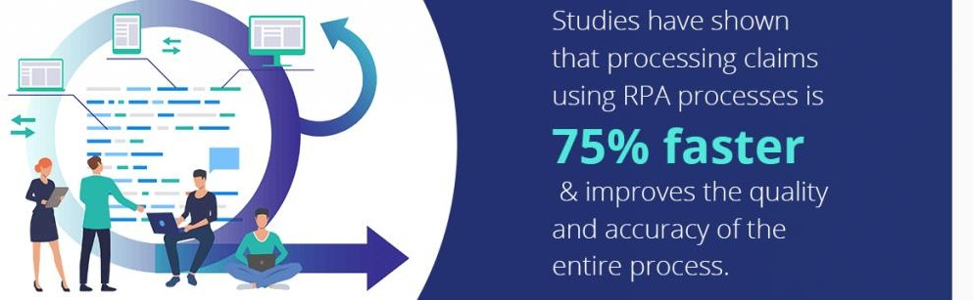

Collecting important data and automating repetitive tasks is essential for the insurance industry. For ensuring a better customer experience, the insurance industry makes use of the following RPA use cases:

### Processing Claims

Studies have shown that processing claims using RPA processes it 75% faster than the traditional approach. Paper-based processes are eliminated by RPA which improves the quality and accuracy of the entire process.

### Form Registration Process

Insurance automation with RPA speeds up the form registration process by 40%. RPA with artificially intelligent systems reduces the workload significantly and ensures customer satisfaction.

### Regulatory Compliance Updates Made Simpler

Insurance firms rely on several compliance standards and policies. For instance, the [HIPAA privacy](https://www.jotform.com/what-is-hipaa-compliance/) [rules](https://www.jotform.com/what-is-hipaa-compliance/) and PCI standards can vary and banks can help their clients stick to these compliance standards by making use of automated notifications and updates using RPA strategies.

### Risk Mitigation

RPA allows risk mitigation via RPA by being able to accurately process data automatically from both internal as well as external sites. This ensures delivery of work at a faster pace and with 100% accuracy.

## RPA in Healthcare Industries

With the growing volume of patients, healthcare industries are prioritizing on cost reduction and efficiency as two major benefits of RPA implementation in healthcare services. The key RPA use cases in healthcare are as follows:

### Savings on Human Workforce

Replacing the workforce that performs mundane and repetitive tasks can be replaced with RPA implementation. This helps the workforce from spending time on core activities rather than perform intense and mundane tasks.

### Increased Throughput with Improved Quality

Healthcare personnel can now tackle the large volume of patients, especially in providing individual care and attention. Maintaining medical records of patients, entry processing, claim processing, etc are automated with lower costs via RPA implementation.

## RPA in Manufacturing Industries

Robotic process automation has made manufacturing companies shift their production units to automated software bots. Assembling of products, quality checking and packaging and back-end processes have obtained a 40% savings in operational costs via automation. The major use cases are as follows:

### BOM Made Simple

The Bill Of Materials with the list of raw materials for new product creation provides detailed information. Leveraging RPA makes product creation faster and ensures accurate and timely creation.

### Data Migration

Unlike traditional data migration, implementing RPA provides proper planning and execution of moving data from old to new systems, ensuring cost and time savings.

### ERP Automation

Planning of resources is made easier with RPA implementation. Managing Inventory, Accounts Payable, Receivable, and other reports are generated automatically.

## Apart from these key areas, other industries that leverage robotic process automation strategies are as follows:

**RPA in Finance**

Managing customer accounts, creating various reports, migrating data between accounts, updating loan and mortgage data, etc are major applications

of RPA in the finance sector. RPA helps financial services meet compliance standards with changing rules.

RPA technology is accurate and hence implementing RPA in financial services provide significant risk reduction. Faster RPA cycles enhance finance processes, is highly scalable and rapidly deployable.

## RPA in Property Management

Property owners are able to manage their property units systematically with RPA. Automated processes help property owners reduce the turnaround time, improve the efficiency of business processes, and save costs.

## RPA in Retail Sector

RPA provides the retail industries with solutions such as automatic inventory monitoring, email sales, extraction of critical information from manufacturer websites, etc.

## RPA in Information Technology Industries

From employee on boarding, due diligence, payroll processing, task tracking to CRM updating, leveraging RPA in the Information Technology sector can benefit by automating the highly repetitive tasks. Additionally, it helps in saving costs and time.

# Risks & Challenges with RPA:

Robotic process automation (RPA) is a powerful tool that can help businesses save time, money, and improve efficiency. However, like any new technology, there are risks and challenges associated with RPA.

## Some of the key risks of RPA include:

* **Security risks**: RPA bots can access sensitive data, which could be used for malicious purposes. It is important to implement security controls to protect data from unauthorized access.
* **Process interruption:** If an RPA bot fails, it could disrupt the underlying business process. It is important to have a plan in place to handle bot failures.
* **Employee resistance:** Some employees may be resistant to change, and may see RPA as a threat to their jobs. It is important to communicate the benefits of RPA to employees, and to help them transition to new roles.
* **Technical challenges:** RPA can be complex to implement, and there may be technical challenges along the way. It is important to have a team of experienced RPA professionals to help with implementation.

## Some of the key challenges of RPA include:

* **Lack of skilled resources:** There is a shortage of skilled RPA professionals, which can make it difficult to find and hire the right people for RPA projects.
* **Choosing the right processes to automate**: Not all processes are good candidates for automation. It is important to choose processes that are repetitive, rule-based, and have a high volume of transactions.
* **Managing change:** RPA can lead to significant changes in the way businesses operate. It is important to manage change effectively to ensure a smooth transition.

Despite the risks and challenges, RPA can be a valuable tool for businesses. By carefully managing the risks and challenges, businesses can reap the benefits of RPA, such as increased efficiency, reduced costs, and improved customer service.

Here are some tips for mitigating the risks and challenges of RPA:

* **Implement security controls:** This includes using encryption, access controls, and monitoring tools to protect data from unauthorized access.
* **Have a plan for bot failures:** This includes having a way to detect and recover from bot failures, as well as a way to notify stakeholders of the failure.
* **Communicate the benefits of RPA to employees**: This will help to reduce resistance to change and ensure that employees are on board with the RPA initiative.
* **Hire experienced RPA professionals**: This will help to ensure that the RPA project is implemented correctly and that the risks are mitigated.
* **Choose the right processes to automate:** This will help to ensure that the RPA project is successful and that the benefits are realized.
* **Manage change effectively:** This will help to ensure that the RPA project is implemented smoothly and that the business can adapt to the changes.

By following these tips, businesses can mitigate the risks and challenges of RPA and reap the benefits of this powerful technology.

# RPA and emerging ecosystem

Robotic process automation (RPA) is a rapidly growing technology that is being used by businesses of all sizes to automate repetitive and rule-based tasks. As RPA adoption continues to grow, an emerging ecosystem of complementary technologies is developing to support it.

## Some of the key technologies that are emerging in the RPA ecosystem include:

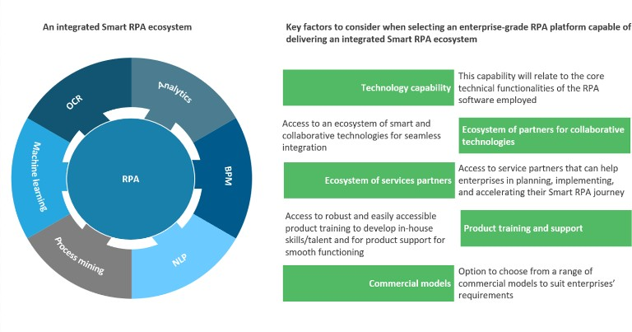

* + **Low-code/no-code development platforms:** These platforms make it easier for businesses to develop and deploy RPA bots without the need for specialized coding skills.
  + **Process mining:** This technology helps businesses to identify and optimize their business processes, which can then be automated with RPA.
  + **Artificial intelligence (AI):** AI is being used to extend the capabilities of RPA, such as by enabling bots to learn and adapt to new situations.
  + **Machine learning (ML):** ML is being used to automate tasks that were previously thought to be too complex for RPA, such as natural language processing (NLP).

The emergence of this RPA ecosystem is making it easier for businesses to automate their processes and achieve significant benefits, such as:

* + **Increased efficiency:** RPA can help businesses to automate repetitive tasks, which can free up employees to focus on more strategic work.
  + **Reduced costs:** RPA can help businesses to reduce costs by eliminating the need for manual labor.
  + **Improved accuracy:** RPA can help businesses to improve the accuracy of their processes by eliminating human error.
  + **Enhanced customer service:** RPA can help businesses to improve customer service by automating tasks such as answering customer questions and processing orders.

The RPA ecosystem is still in its early stages, but it is growing rapidly. As the ecosystem continues to develop, businesses will have even more opportunities to automate their processes and achieve significant benefits.

In addition to the technologies mentioned above, there are a number of other emerging technologies that have the potential to impact the RPA ecosystem. These include:

* + **Block chain:** Block chain could be used to create a secure and transparent way to store and share data, which could be beneficial for RPA applications.
  + **Quantum computing:** Quantum computing could be used to speed up the processing of complex tasks, which could make RPA more feasible for some applications.
  + **Edge computing:** Edge computing could be used to deploy RPA bots closer to the data sources, which could improve performance and reduce latency.

The RPA ecosystem is constantly evolving, and it is difficult to predict which technologies will have the biggest impact in the future. However, it is clear that the ecosystem is poised for significant growth, and businesses that are looking to automate their processes should keep an eye on the latest developments.